Baby talk helps infants learn language faster

Talking in a high pitch 'baby voice' to children helps them learn language quicker and pick up more words by the age of two, researchers have found.
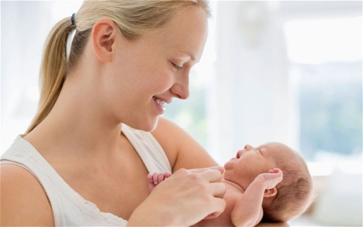

Talking in a baby voice is the best way to encourage children to pick up a language, according to research Photo: Alamy
By Sarah Knapton, Science Correspondent 7:00AM GMT 08 Jan 2014
Cooing at children may be frowned upon by some parenting manuals but new research suggests baby talk helps youngsters pick up language faster.
Researchers found that infants whose parents talked to them at a higher pitch and with elongated vowels had learned nearly three times more words by the age of two.
Researchers at the University of Washington and University of Connecticut examined thousands of 30-second snippets of verbal exchanges between parents and babies.
"What our analysis shows is that the prevalence of baby talk in one-on-one conversations with children is linked to better language development." said Patricia Kuhl, co-author and co-director of UW's Institute for Learning & Brain Sciences.
The more parents exaggerated vowels – such as "How are youuuuu?" – emphasised important words, spoke more slowly using a happy tone of voice and raised the pitch of their voices, the more the one-year olds babbled, a forerunner of word production.

Singing to children may help development of language skills
New book claims that 'signature' melodies and inflections of traditional rhymes prepare children's brains for language
Amelia Hill Sunday 8 May 2011
Parents should sing to their children every day to avoid language problems developing in later life, according to a consultant. Too much emphasis in the early years is placed on reading, writing and numeracy, and not enough on the benefits of singing, according to Sally Goddard Blythe, a consultant in neuro-developmental education and director of the Institute for Neuro-Physiological Psychology.
Singing traditional lullabies and nursery rhymes to babies and infants before they learn to speak, is "an essential precursor to later educational success and emotional wellbeing", argues Blythe in a book. "Song is a special type of speech. Lullabies, songs and rhymes of every culture carry the 'signature' melodies and inflections of a mother tongue, preparing a child's ear, voice and brain for language." Blythe says in her book, The Genius of Natural Childhood, to be published by Hawthorn Press, that traditional songs aid a child's ability to think in words. She also claims that listening to, and singing along with rhymes and songs uses and develops both sides of the brain. "Neuro-imaging has shown that music involves more than just centralised hotspots in the brain, occupying large swathes on both sides," she said.
Growing numbers of children enter nursery and school with inadequate language and communication skills, according to the National Literacy Trust, often because their parents have not helped them develop communication skills. Blythe believes that singing to and, later, with a child is the most effective way to transform their ability to communicate.
"Children's response to live music is different from recorded music," she said. "Babies are particularly responsive when the music comes directly from the parent. Singing along with a parent is for the development of reciprocal communication."
Beverley Hughes, the former children's minister who established a national curriculum to set down how babies are taught to speak in childcare from the age of three months, agreed that nursery rhymes can "boost child development".
Hughes cites research showing that music and rhyme increase a child's ability in spatial reasoning, which can enhance a child's mathematical and scientific abilities.
"Singing nursery rhymes with young children will get them off to a flying start," she said.
Daniel Dwase, editor of the online Child Development Guide, agreed that nursery rhymes set to music can aid a child's development. But, he added, teaching a child to dance is also important.
"Music assists in the development of a child's speech," he said. "Singing nursery rhymes and simple songs teaches children how language is constructed and assists with the acquisition of language. Singing songs with your child will also teach them about tone, beat and rhythm.
"Even better than just singing, though, is to teach songs with actions and encourage your child to dance along to the music, they will learn balance, co-ordination, body awareness and rhythm," he said.END

